TotalVar origin 3342554413805.776

totalVarPCA 3342554413805.776

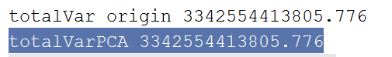

Yes They are the same

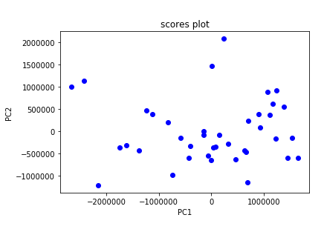

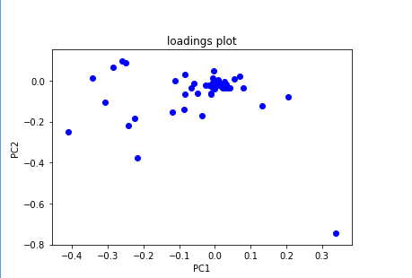



0.75\*3342554413805.776=2.5691581\*10^12

With 41 number of PCAs



With 40 number of PCAs

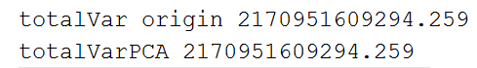

Therefore, I think we must keep 41 number of PCAs out of 49.

Yes , they are diff after standardization